**Searching for a Specific User and Updating the User Information : Output**

1. Database of Customer(Before updating)

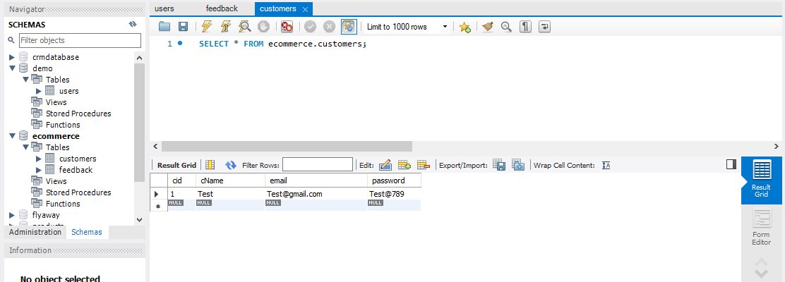

1. Index.jsp page

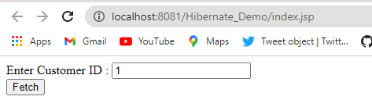

1. Edit Customer Form

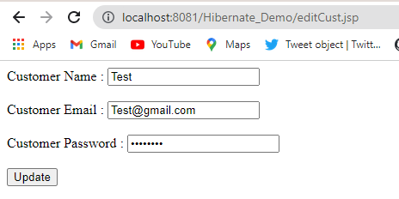

1. Editting the values of the form

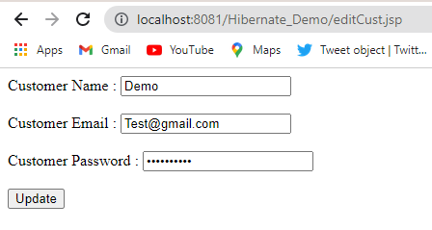

1. Success Message after clicking on Update button

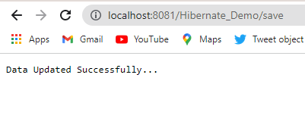

1. Database after updating the values

